Audit Report for **PeThao**

Date: 23 July 2024

Audit result: **Passed with High Risk**

**Token Address:** 0x8Cb3C955691fA2185AB211Df341d2561c6AAE5d8

**Name:** PeThao

**Symbol:** PETHAO

**Decimals**: 9

**Network:** Bsc Scan

**Token Type**: BEP-20

**Owner**: 0x15cC222BB37A2A4A9af86033fc90f8bdF7019A86

**Deployer:** 0x15cC222BB37A2A4A9af86033fc90f8bdF7019A86

**Token Supply:** 1,000,000,000

**Checksum:** 509f98d5565a2ff955f24ddff42fd7b251bf30fc

**Testnet:**

https://testnet.bscscan.com/address/0xb01c0a21e6f372928ed132b52568ff0b029d4ec5

**Token Overview:**

**Buy Fee:** 0-0%

**Sell Fee:** 0-0%

**Transfer Fee:** 0-0%

**Fee Privilege:** Owner

**Ownership:** Owned

**Minting:** None

**Max Tx:** No

**Blacklist:** No

**Inheritance Tree** 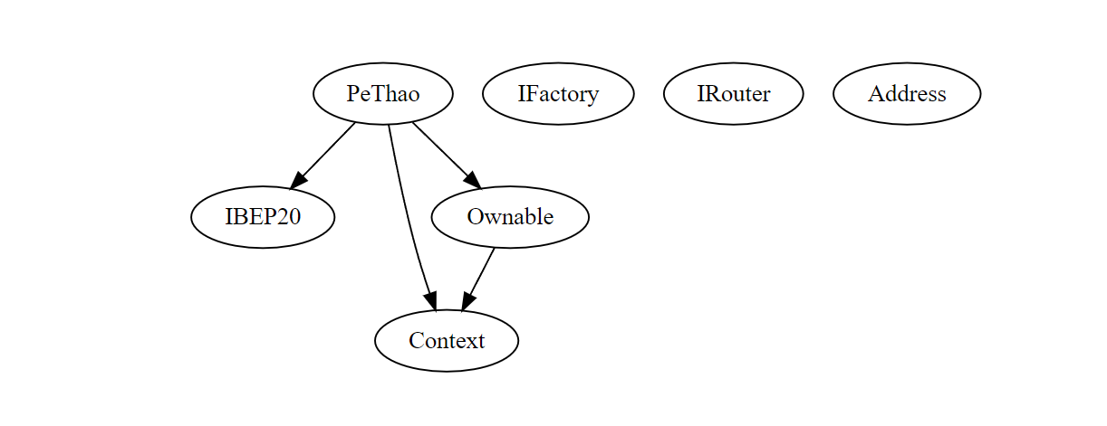

**Static Analysis**

A static analysis of the code was performed using Slither. No issues were found.

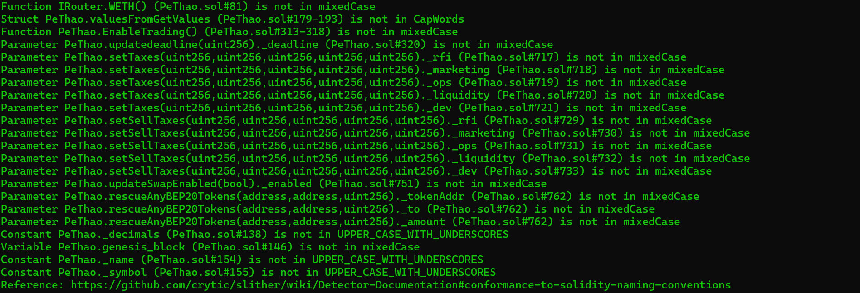

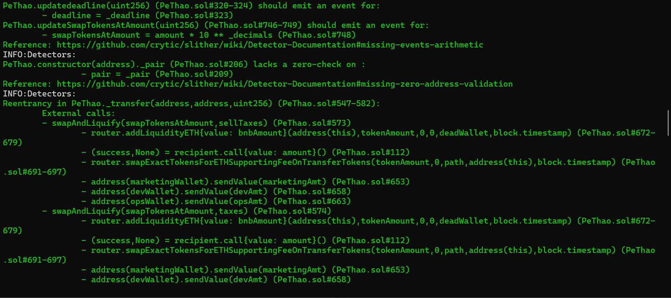

**Functional Tests**

**Router (PCS V2):**

**1- EnableTrading (passed):**

<https://testnet.bscscan.com/tx/0x724929a903c75e8d12ce38a433e0e8d48afd08ccbeb665298f85e9073dbd1915>

**2- Approve (passed):**

<https://testnet.bscscan.com/tx/0xdb27102bd5199adc2ef5cc9fd5ac9f9149ad1ac82ef610120c1b39f8fb76c1a4>

**3- bulkExcludeFee (passed):**

<https://testnet.bscscan.com/tx/0x90fc852aeb327af9f492b2a4b2685b2ac077eb2cb9a9d13121f6ded90ca6c713>

**4- renounceOwnership (passed):**

<https://testnet.bscscan.com/tx/0xb352bf5433cf5e62d3e499efe042008154651cf48fabe6f7a3d052f37f0dd4da>

**5- transfer (passed):**

<https://testnet.bscscan.com/tx/0x3c51a5ec5a0a8c02b062f23faf20636117e1a36a93a201c970541c0f03cacbdf>

**Ownership Privileges:**

- The owner can exclude/includeFrom/InReward.

- The owner can update deadline.

- The owner can Enable trading.  
- The owner can exclude/includeFrom/InFee.

- The owner can Set Taxes.  
- The owner can set Sell Taxes not more than 10%.  
- The owner can rescue BNB.

- The owner can bulkExcludeFee.  
- The owner can update marketing wallet.  
- The owner can update dev wallet.  
- The owner can update marketing wallet.

- The owner can update Swap tokens at amount.  
- The owner can update marketing wallet.  
- The owner can rescue any BEP20 Tokens.

**Findings:**

**Critical**: 0

**High**: 1

**Medium**: 1

**Low**: 2

**Informational** **&** **Optimizations**: 1

**Centralization – Enabling Trades**

**Severity**: **High**

**Function**: EnableTrading

**Status:** Open

**Overview:**

The **EnableTrading** function permits only the contract owner to activate trading capabilities. Until this function is executed, no investors can buy, sell, or transfer their tokens. This places a high degree of control and centralization in the hands of the contract owner.

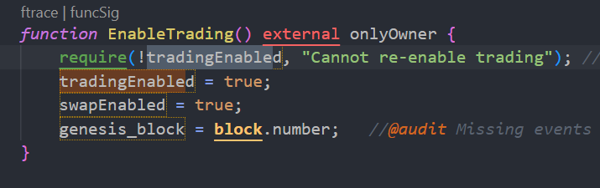

**Suggestion:**

To reduce centralization and potential manipulation, consider one of the following approaches:

1. Automatically enable trading after a specified condition, such as the completion of a presale, is met.
2. If manual activation is still desired, consider transferring the ownership of the contract to a trustworthy, third-party entity like a certified "PinkSale Safu" developer. This can give investors more confidence in the eventual activation of trading capabilities, mitigating concerns of potential bad-faith actions by the original owner.

**Centralization – Missing Require Check.**

**Severity**: **Medium**

**Function**: updateMarketingWallet/updateDevWallet /updateOpsWallet

**Status:** Open

**Overview:**

The owner can set any arbitrary address excluding zero address as this is not recommended because if the owner will set the address to the contract address, then the Eth will not be sent to that address and the transaction will fail and this will lead to a potential honeypot in the contract.

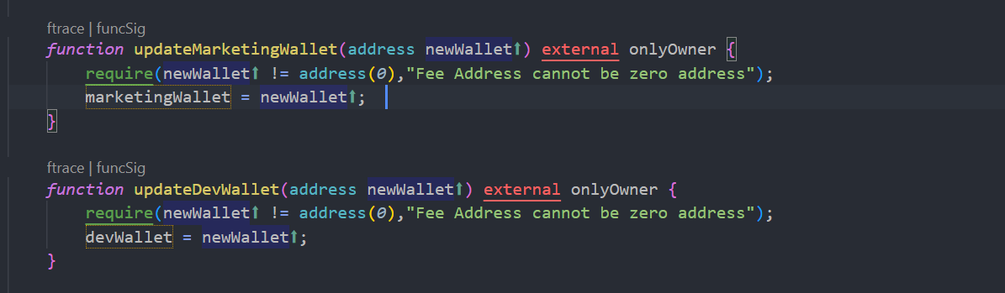 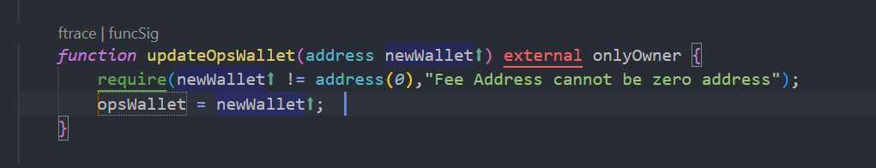

**Centralization – Missing Events**

**Severity**: **Low**

**Subject**: Missing Events

**Status:** Open

**Overview:**

They serve as a mechanism for emitting and recording data onto the blockchain, making it transparent and easily accessible.

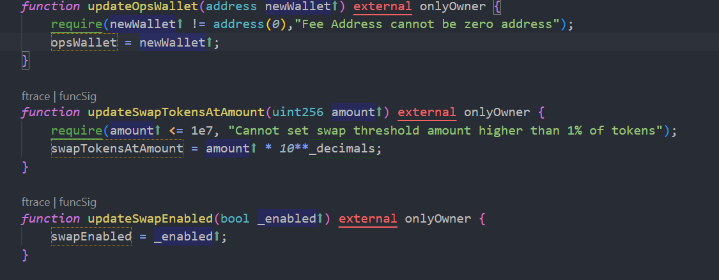

**Suggestion:**

Emit an event for critical changes.

**Centralization – Local variable Shadowing**

**Severity**: **Low**

**Subject**: Variable Shadowing

**Status:** Open

**Overview:**

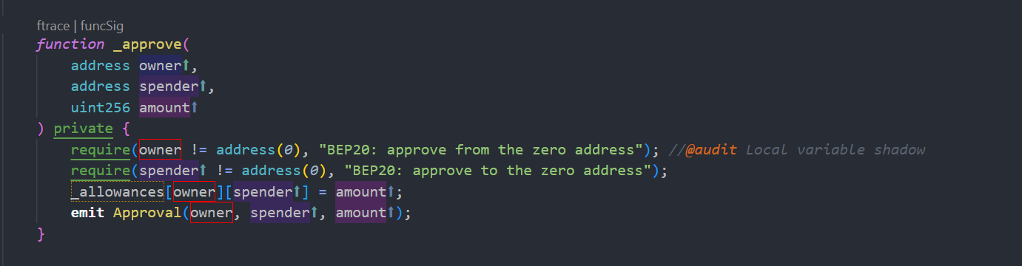

**Suggestion:**

Rename the local variables that shadow another component.

**Optimization**

**Severity**: **Informational**

**Subject**: Floating Pragma.

**Status:** Open

**Overview:**

It is considered best practice to pick one compiler version and stick with it. With a floating pragma, contracts may accidentally be deployed using an outdated.



**Suggestion:**

Adding the latest constant version of solidity is recommended, as this prevents the unintentional deployment of a contract with an outdated compiler that contains unresolved bugs.